www.merrylandsmusic.com.au (Phone 02-96377011)

Authorised shop-front retailer of ZOOM products in Australia

With Australian Guarantee

R16 - Handy Video Recorder/Interface/Controller for $699 (RRP $879)

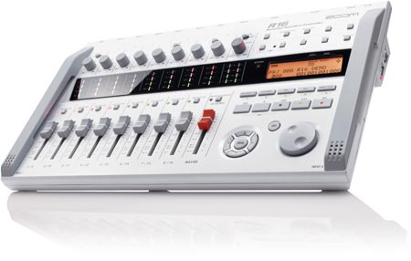
Click here to watch the Zoom R16 Product Video!
Listen to Richie Kotzen's band recorded live with the Zoom R16.
Zoom revolutionizes recording with the first digital recorder with 16-track playback and 8-track simultaneous recording that uses Secure Digital (SD) memory. The new R16 recorder is three production tools in one incredibly versatile device. It's a digital multi-track recorder, an audio interface and a control surface, providing you with all the tools necessary to create studio-quality recordings anywhere.
The R16 combines a remarkable level of functionality with exceptionally intuitive design. For recording purposes, the unit supports up to 32GB SD cards, allowing over 100 track hours of recording. The flexibility of SD recording not only makes the R16 lighter and more portable, it also ensures increased reliability with no concern for a crashing hard drive. You can even have respective SD cards dedicated to specific recording sessions. Back up your project on a USB memory stick.
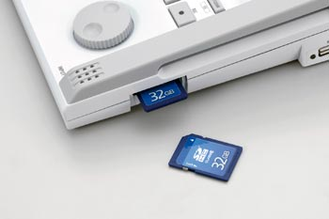
With the ability to record up to 8 tracks simultaneously, it's easy to capture a live band or even a complete drum kit. The R16 features built-in stereo condenser microphones for field recording or quick, convenient "sketch-pad" capturing of ideas and rehearsals. It also provides 8 combination XLR-1/4-inch inputs along with one Hi-Z input for direct connection of guitar or bass. And the R16 also runs on 6 AA batteries for the ultimate in multi-track portability.
USB operation means you can control each function of your favorite DAW software from the R16 for easy mixing with fine-tuned control. Incorporate any of the 100+ built-in studio effects to enhance your recording and use the pro-quality mastering effects to complete that studio sound. You can even connect two R16s via USB for synchronized operation and 16 tracks of simultaneous recording.
With the new Zoom R16, versatility, control and comprehensive features come together in a single device that puts the power to produce professional recordings right at your fingertips.

Using the R16 for Music
It's a Recorder...
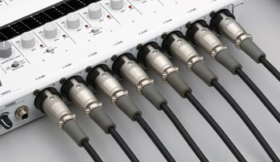
With the ability to record up to 8 tracks simultaneously, the R16 is perfect for recording everything: from music production and rehearsals to field recording and live performances. The R16 also features the same built-in stereo condenser microphones found on an H4 for convenient "sketch-pad" capturing of ideas or rehearsals.
Use the Hi-Z inputs for direct connection of guitar or bass, and get rocking with built-in guitar and bass amp and effects models. When your masterwork is ready, you can use over 100 built-in studio effects to enhance your tracks and use the pro-quality mastering effects to complete that studio sound.
It's an Interface.
The R16 is more than a multi-track recorder. It's also a powerful workstation when using USB power for studio operation. Connect the R16 to your laptop or desktop computer via USB, launch your favorite DAW or use the included Cubase LE 4, and start laying down your production tracks. With the 8 balanced, combination XLR-1/4-inch inputs 2 outputs (8 x 2), you can record high-definition, 24-bit/96kHz audio (2 x 2). Use the R16's built-in effects as you lay down tracks on your computer.
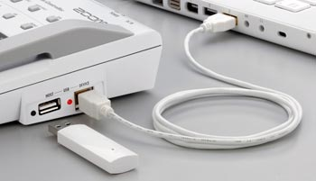
It's a Controller!
Computers bring incredible control and power to the recording process, but they're not very intuitive when it comes to mixing. And mixing makes the music. So, when you're ready to mix, the R16 is right there with you. With its USB operation, you can control the functions of your DAW software from the R16 for easy mixing with fine-tuned control. No more mixing with a mouse! The R16's intuitive, mixing console feel, and LED meter bridge makes mixing your tracks a pleasure.
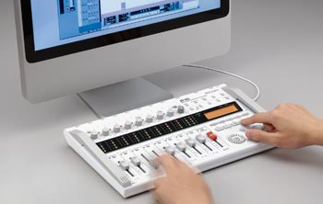

Using the R16 for Video Applications
For media and filmmakers, the R16 makes it easy to record audio with booms, handheld mics or up to 8 lavaliers with wireless setups. Great for sound effects recording or anyone looking for multiple audio feeds in a remote environment, the R16 is lightweight, portable solution to your location video shoot needs.
Location shoots
Perfect for shooting on location, the R16 is well-suited for corporate event shoots where there are multiple speakers, industrials, education settings, talk shows or panel discussions where you don't want to compromise audio quality even with budget limitations that pervade today's media environment.
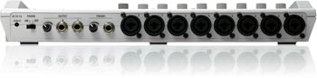
Of course, the R16 includes a stereo headphone output for continuous monitoring and with the LED meter bridge, its easy to be sure all your levels are set appropriately for the source.
Good to Go...
Best of all, the R16 will operate for almost 5 hours on 6 standard AA batteries, making it convenient to run on location without the added complication of charging battery packs. Use the R16 as a battery powered mixer, even when you're not recording!
Post-production
Transfer large amounts of audio in no time with the USB 2.0 interface that makes the R16 a drag and drop time saver and a pleasure to use. That means less time in post is spent building up your project, especially when you're using the R16 to gather natural sound on a shoot.
Because the R16 is also a control surface, it becomes a convenient audio editing tool using a variety of video editing software packages such as Final Cut Pro. Or use the onboard mixer to create a mix on the fly and bounce to a stereo master using the built-in mastering effects to sweeten the tracks.
Ready for V/O
Sometimes a project calls for additional voiceover tracks, either on location as a "scratch track" or in the editing studio. And with phantom power, high-quality mic preamps and vocal effects onboard, the R16 is ready to roll in any situation.
Expand your horizons.
Expandability is often a big part of using a piece of gear on location. With the R16, you can connect two R16 units via USB, one can be designated to function as the USB master and the other as the USB slave, allowing synchronized transport operation and recording on 16 tracks simultaneously.
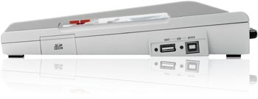
Built-in high-sensitivity stereo microphones
When you want to quickly record natural sound or room audio from the location, the R16's built-in set of stereo mics will come in handy. Sound effects, speeches or dialog can be captured with excellent clarity. With the R16, versatility, control and portability come together in one recorder that lets you produce professional results everywhere you go.
Zoom R-16 Features
Digital recorder with 16-track playback and 8-track simultaneous recording utilizing Secure Digital (SD) memory
16/24-bit/44.1kHz linear PCM recording in WAV format
Built-in stereo condenser microphones
Includes 1GB SD card and supports cards up to 32GB SDHC
Allows simultaneous recording on up to 8 tracks
Battery operation for remote recording
USB power for audio interface and control surface operation
8 mic inputs / 2 outputs (8 x 2)
8 combination XLR-1/4-inch inputs
High-definition 24-bit/96kHz recording capability using digital audio software
Built-in effects can be used as outboard effects as well
Hi-Z input for direct connection of guitar or bass
Includes preamp with phantom power on two channels
Mackie control emulation via USB for popular DAW software including Cubase, Logic, Digital Performer and more
Over 100 built-in studio effects coming from advanced DSP
Amazing guitar amp and effects models
Professional quality mastering effects including multi-band compressor, normalizer and more
Operates as USB storage device for quick data transfer
Connect two R16s via USB for synchronized operation and 16 tracks of simultaneous recording
Undo/Redo functions
Comes with Steinberg Cubase LE 4
Supports Windows XP/Vista, Mac operating systems

www.merrylandsmusic.com.au (Phone 02-96377011)

Authorised shop-front retailer of ZOOM products in Australia

With Australian Guarantee

